< Header: Insert your organisation’s logos >

< Insert Place, date >

Dear < Insert candidate MP of your constituency >,

With the entry into force of the Lisbon Treaty, the European Parliament has become a powerful co-legislator and plays a determining role in shaping European policies and legislations. A vote in the European elections is every citizen's chance to influence the shape of the Parliament and the decisions it takes over its five-year mandate.

Ahead of the European Parliament elections that will be held between 22 and 25 May 2014, we call on you, < Insert name of candidate MEP >, to ensure the rights of all children around the world are respected and fulfilled. All 28 EU Member States have endorsed the UN Convention on the Rights of the Child; the Lisbon Treaty makes the promotion of children’s rights an explicit objective of EU internal and external affairs and the EU Charter of Fundamental Rights requires that the best interests of the child is a primary consideration in all EU actions. It is now time to translate these commitments into concrete results for children.

Children are disproportionately affected by the economic crisis, poverty, emergency and conflict situations. Worldwide, around 600 million children live in poverty, and more than one in four inside the EU. In only one year the number of children at risk of poverty or social exclusion increased by half million in the EU. By 2050, almost 70 per cent of the world’s children will live in poor and fragile countries. In a world of plenty, thirteen children under the age of five still die of preventable causes every minute. How Europe treats children inside the EU and around the world will determine its future. Building inclusive, stable, democratic and prosperous societies starts with upholding children’s rights and investing in their future.

As outlined in the attached Child Rights Manifesto, drafted jointly by fourteen child and youth-focused international organisations, the next European Parliament must have the institutional capacity to promote the interests of children in every aspect of its work and hold EU institutions to account for the implementation of existing legal obligations. As a current or candidate MEP, you can make a difference by encouraging governments, EU institutions, Member States, including our own, and development partners to place children’s rights at the heart of all policies and actions, to allocate sufficient funding from the EU instruments to children, and to engage children in decision-making. The EU should develop a robust successor to the EU Agenda on the Rights of the Child, which ends in 2014, as well as champion and implement a comprehensive post-2015 agenda that mainstreams their rights.

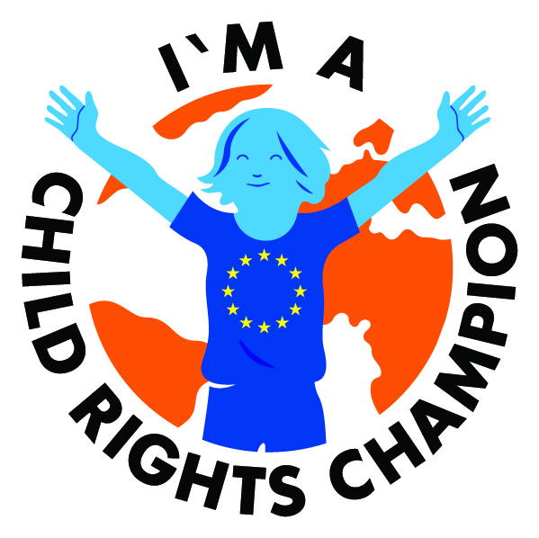
With great power comes great responsibility. As current or future member of the European Parliament, make a commitment to be a Child Rights Champion!

How to endorse and promote children’s rights:
- Sign the manifesto on the website: www.childrightsmanifesto.eu
- Promote the manifesto via Twitter using #childrightschampion

A list of candidate MEPs who have signed the Child Rights Manifesto will be published and made available to the public in advance of the European Parliament Elections in May.

Sincerely,
< Insert signature >

